Tutorial Three
Alternative Forms of Engagement
Over the past few weeks, we have examined a number of models of discrimination. In this tutorial, we are going to apply that knowledge and practice communicating it to other people. Your goal this tutorial is to make memes that teach people about discrimination.

Directions
- Get in a group of three individuals.
- Go on TikTok, Instagram, and Twitter. Search for content about discrimination.
  - How are people discussing discrimination? Is it videos, pictures, threads? Are the modes of communication similar across platforms or platform specific? Why do you think there are commonalities or differences?
  - Which models are most common? Do you think these are accurate portrayals of the theory?
  - How are people discuss discrimination? What evidence are they using? How are they making their point (i.e., outrage, humor, data driven facts, lived experiences)?
  - Go to https://imgflip.com/memetemplates
    - Using one of the templates, make a meme which expresses a concept from one of the models of discrimination.

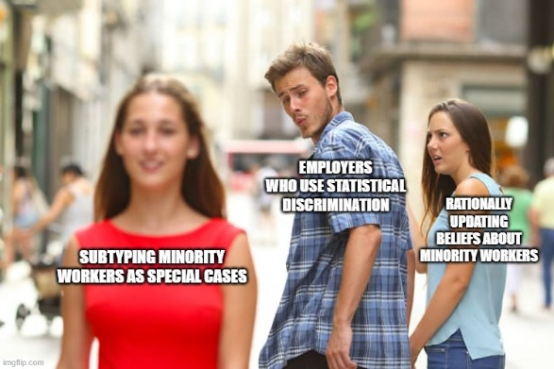
Examples from last year
